**Azure boards:**

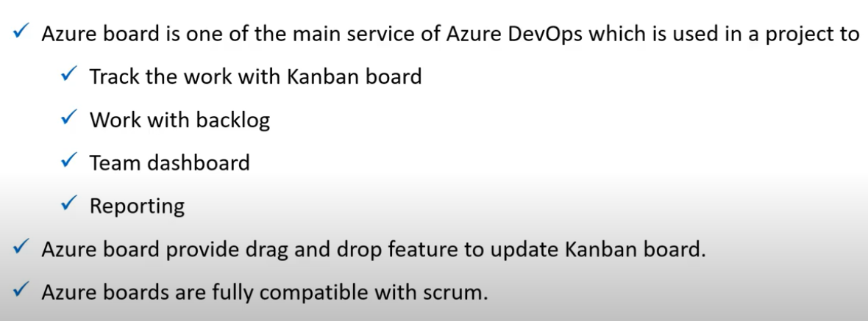

* It is used to trach the work.
* Kanban board will have the details work which we will be going to deliver.
* Backlog is the work which need to be delivered in upcoming sprint. Those details will be in backlog.
* There maybe multiple teams working for a particular project. Creating a board for each team is called team dashboard.
* Reporting provides different types to charts for reports.

